## Samuel Pires 60718

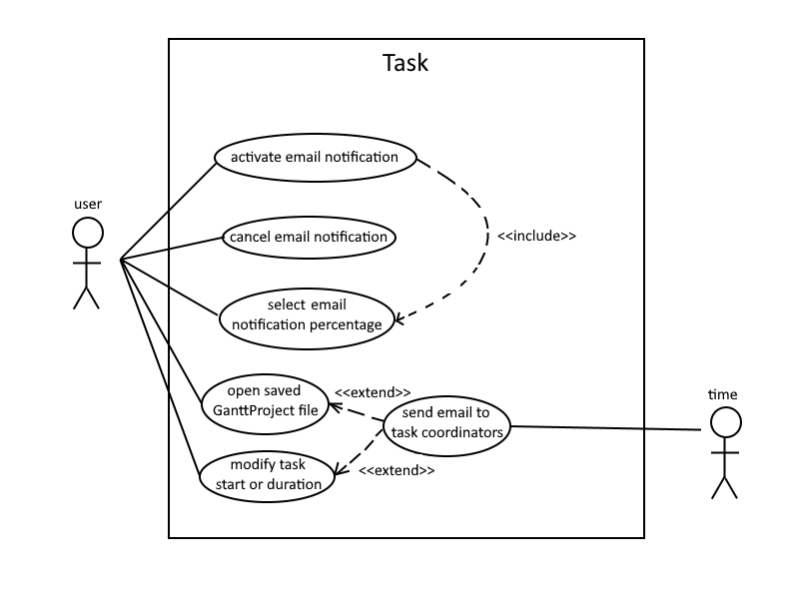

**Actor(s)**: The current user of the program and time.

**Activate Email Notification**

Description: The user activates the Email Notification feature on the task.

**Cancel Email Notification**

Description: The user deactivates the Email Notification feature on the task.

**Select Email Notification Percentage**

Description: The user selects an available percentage on the task’s duration for the Email Notification feature.

**Open Saved GanttProject File**

Description: The user edits the name of an existing objective of a task in the program.

**Modify Task Start or Duration**

Description: The user changes the task’s start and/or duration values.

**Send Email to Task Coordinators**  
Description: If the Email Notification feature is activated, when enough time has passed to reach the current task’s selected percentage, an email is sent to all its coordinators.   
It can also happen that the user opens a saved GanttProject file which has an email that should’ve been sent while the app was closed, or changes the task’s start and/or duration in a way in which the selected percentage has already passed. In both of these cases, the email is sent immediately.